**AP2 - Introdução a Computação**

1. **Preencha a tabela abaixo, respeitando as bases:**

| **Decimal** | **Binária** | **Octal** | **Hexadecimal** |
| --- | --- | --- | --- |
| 10 | 1010 | 12 | A |
| 11 | 1011 | 13 | B |
| 12 | 1100 | 14 | C |
| 13 | 1101 | 15 | D |
| 14 | 1110 | 16 | E |
| 15 | 1111 | 17 | F |
| 16 | 10000 | 20 | 10 |
| 17 | 10001 | 21 | 11 |
| 18 | 10010 | 22 | 12 |
| 19 | 10011 | 23 | 13 |
| 20 | 10100 | 24 | 14 |
| 21 | 10101 | 25 | 15 |
| 22 | 10110 | 26 | 16 |
| 23 | 10111 | 27 | 17 |
| 24 | 11000 | 30 | 18 |
| 25 | 11001 | 31 | 19 |
| 26 | 11010 | 32 | 1A |

1. **Risque os números que não fazem parte das bases especificadas:**

| **Binária** | 1100101010100 | ~~1343567347~~ | ~~19643854~~ | ~~F005A~~ |
| --- | --- | --- | --- | --- |
| **Octal** | ~~1100101010100~~ | 1343567347 | ~~19643854~~ | ~~F005A~~ |
| **Decimal** | ~~1100101010100~~ | ~~1343567347~~ | 19643854 | ~~F005A~~ |
| **Hexadecimal** | ~~1100101010100~~ | ~~1343567347~~ | ~~19643854~~ | F005A |

1. **Converta os números abaixo, obedecendo as bases solicitadas:**
2. (11101001)2 = (233)10

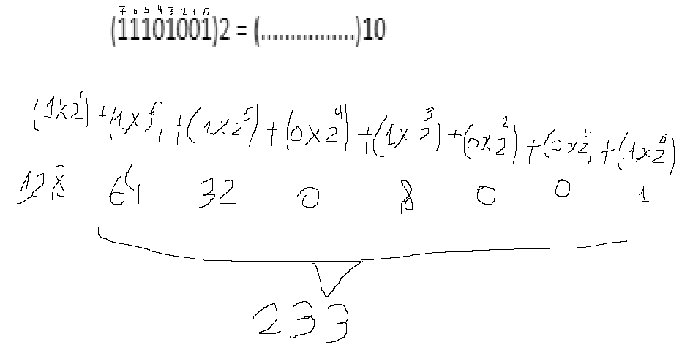

1. (147)10 = (10010011)2

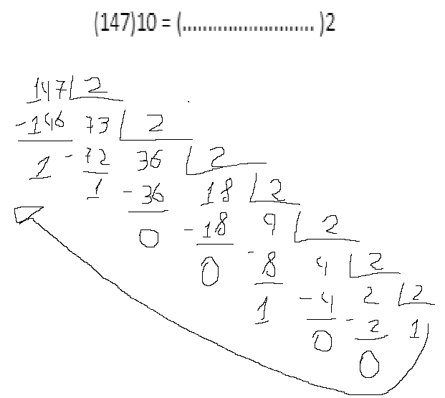

1. (11101001)2 = (E9)16

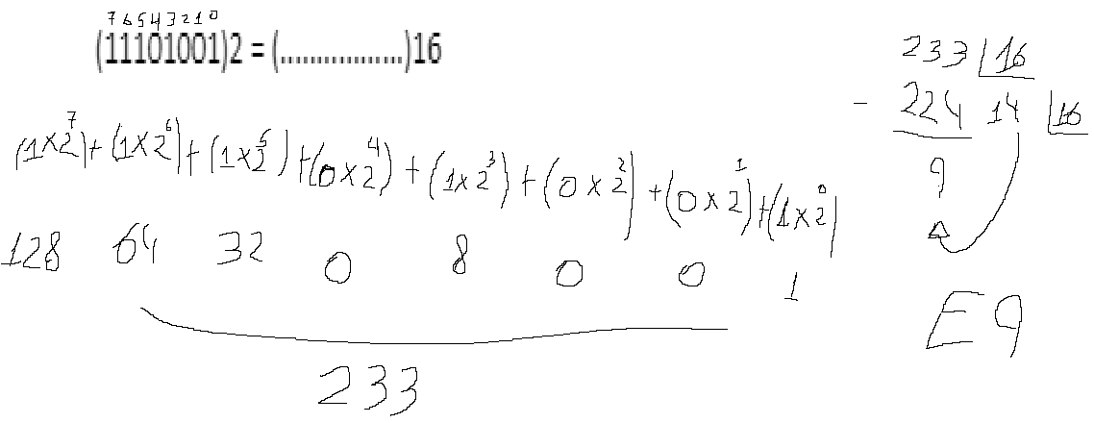

1. (A3)16 = (10100011)2

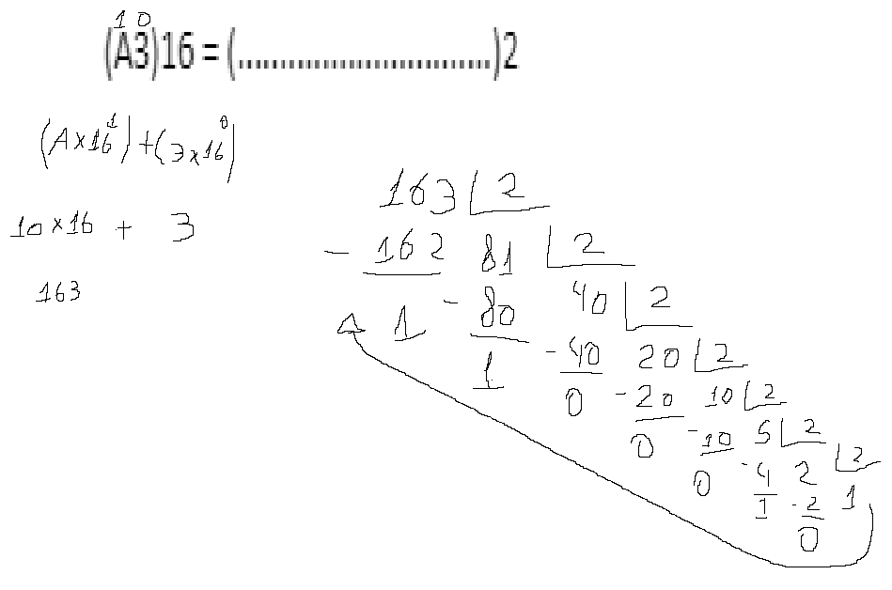

1. (155)8 = (6D)16

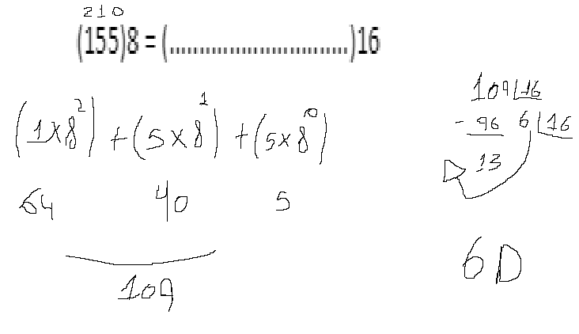

1. (FAB)16 = (7653)8

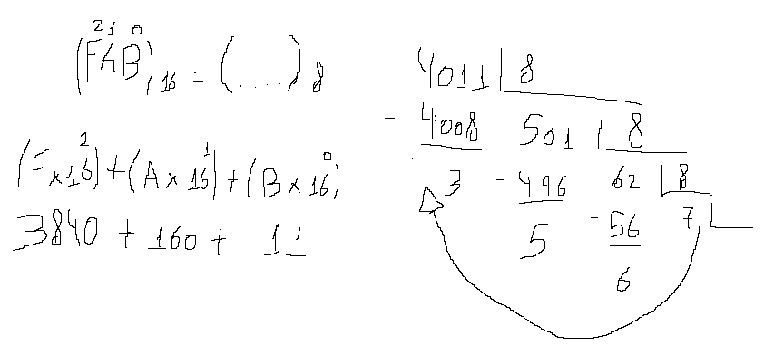

1. (1427)8 = (1100010111)2

